SIMATS ENGINEERING (SAVEETHA SCHOOL OF ENGINEERING)
Department of Computer Science and Engineering
CO2_AT3 — CASE STUDY

Course Code: | DSA06 | Course Title: | Data Handling and Visualization
CO Assessed: | CO2 – Evaluation (BL5) | Assessment: | Assessment Tool 3 – Case Study
Weightage: | 20% of CIA | Total Marks: | 20 (2 Questions × 10 Marks)
CO2 Statement: | Analyze real-world data scenarios and evaluate/justify the most appropriate chart types, coordinate systems, color scales, and dashboard designs to represent them.(BL5)
Student Name: | Haritha S | Reg. No.: | 192324299
Section / Batch: | B.tech – AI&DS | Date: | 01/08/2026

Code of Conduct
I __________________________ (Name / Reg No) certify that this submission is my original work and that I have adhered to the guidelines specified for this assessment. I understand that any violation of academic integrity rules will result in disciplinary action.

Signature of the Student: _________________________

Instructions
- This test contains 2 case-study questions, each carrying 10 marks. Total: 20 Marks.
- No negative marking. Unanswered questions carry zero marks.
- No calculators or electronic devices permitted.
- Duration: 90 minutes.
- Each case study has four sub-parts (a–d); answer all parts for full marks.
- Support your answers with brief calculations or justifications where relevant.
- Diagrams may be hand-drawn or clearly described in words if drawing tools are unavailable.

Annexure A – CASE STUDY

Rubrics for Calculation ASSESSMENT RUBRIC
AT3 — Case Study
CO2 · BT5: Evaluate ·
This rubric is used to assess student responses to the CO2-AT3 Case Study questions, in which students analyze a realistic multi-part scenario and select, justify, design, and critique appropriate visualizations across chart types, coordinate systems, color scales, and dashboard development.

Criteria | Weightage | Level 4 – Exemplary | Level 3 – Proficient | Level 2 – Developing | Level 1 – Beginning
Understanding of Concepts | 25% | Demonstrates thorough understanding of the full range of chart types, coordinate systems, and color scales relevant to the case, and correctly identifies which apply to each sub-part. | Good understanding of the relevant concepts, with only minor gaps in identifying appropriate chart types, scales, or color choices. | Basic understanding, but with some misconceptions about which visualization techniques suit the scenario's data. | Poor understanding of core concepts; proposes techniques fundamentally unsuited to the case study's data.
Explanation | 25% | Provides detailed, well-reasoned justification for every design decision and critique, explicitly tied to specific details of the case. | Provides clear justification for most decisions and critiques, with adequate reasoning. | Justification is limited or generic; decisions are stated without sufficient reasoning tied to the case. | Little or no justification provided; answers are unsupported assertions.
Application | 20% | Effectively applies visualization concepts to analyze and solve every sub-part of the case, including any calculations, with well-reasoned conclusions. | Applies concepts correctly to most sub-parts, with only minor errors. | Limited application; some sub-parts are weakly addressed or only partially correct. | Fails to apply appropriate concepts; sub-parts are left unaddressed or answered incorrectly.
Organization | 15% | The response is clearly structured, addressing every sub-part (a–d) in a logical sequence with coherent overall flow. | The response is organized and addresses each sub-part, with only minor issues in flow or clarity. | Basic structure; sub-parts are addressed but the response lacks clarity or a logical sequence. | Poorly organized; the response is incoherent, and sub-parts are left unaddressed or answered out of order.
Accuracy | 10% | All parts of the answer — chart choices, calculations, critiques, and dashboard design — are completely accurate and well-suited to the case. | Mostly accurate, with only minor omissions or a small error in one sub-part. | Partially correct; some elements are missing, mismatched to the case, or incorrect. | Largely incorrect or inappropriate, with major gaps across multiple sub-parts.

Scoring Guide
For each criterion, award a performance level (1–4) based on the descriptors above. Multiply the level achieved (as a percentage of 4, i.e., Level 4 = 100%, Level 3 = 75%, Level 2 = 50%, Level 1 = 25%) by the criterion's weightage, then sum across all five criteria to obtain the total score out of 100%.

Faculty In-charge | Course Coordinator | Head of Department
Signature: _______________ | Signature: _______________ | Signature: _______________
Date: ___________________ | Date: ___________________ | Date: ___________________

Question 1:
a) Which chart types would you choose to represent (i) the wide-ranging store revenue, (ii) regional profit/loss,
(iii) category composition, and (iv) the ordinal satisfaction data? Justify each choice.
b) Design a one-page dashboard combining at least three of these views, and explain how you would coordinate
them (shared axis, layout, or theme).
c) What color scale would you use for the profit/loss view, and why is it the correct choice for this data?
d) Identify one design flaw a poorly made version of this dashboard might have, and explain how you would fix it.

a) Suitable Chart Types with Justification

(i) Wide-ranging store revenue:
Bar Chart (Horizontal) – A horizontal bar chart is ideal for comparing revenue across multiple stores with large differences in values. It makes it easy to identify the highest- and lowest-performing stores.
(ii) Regional profit/loss:
Diverging Bar Chart – Since profit and loss contain both positive and negative values, a diverging bar chart clearly separates profits (positive) from losses (negative) around a zero baseline.
(iii) Category composition:
Pie Chart – A pie chart effectively shows how each product category contributes to the total, making it suitable for displaying composition or proportions.
(iv) Ordinal satisfaction data:
Ordered Bar Chart – Satisfaction levels (e.g., Poor, Fair, Good, Very Good, Excellent) have a natural order, so an ordered bar chart preserves this ranking and allows easy comparison of frequencies.

b) One-Page Dashboard Design

Dashboard Layout:

----------------------------------------------------
Store Revenue (Horizontal Bar Chart)
----------------------------------------------------
Regional Profit/Loss | Category Composition (Pie)
----------------------------------------------------
Customer Satisfaction (Ordered Bar Chart)

Coordination:
- Use a consistent color theme throughout the dashboard.
- Align charts using a common layout with equal spacing.
- Use shared fonts, titles, and legends for consistency.
- Keep bar charts on comparable scales where appropriate.
- Arrange the charts so users can move naturally from overall performance (revenue) to profitability, composition, and customer feedback.

c) Colour Scale for Profit/Loss

Use a diverging colour scale:
- Green → Profit (positive values)
- Red → Loss (negative values)
- White or Gray → Zero
Reason:
A diverging colour scale is appropriate because the data contains both positive and negative values, making it easy to distinguish profitable regions from loss-making regions.

d) Design Flaw and Fix
Design Flaw:
Using 3D charts (especially 3D pie charts) can distort the sizes of bars or slices, making comparisons inaccurate.
Fix:
Use 2D charts with clear labels, consistent scales, and simple colors. This improves readability and ensures accurate interpretation of the data.

Conclusion:

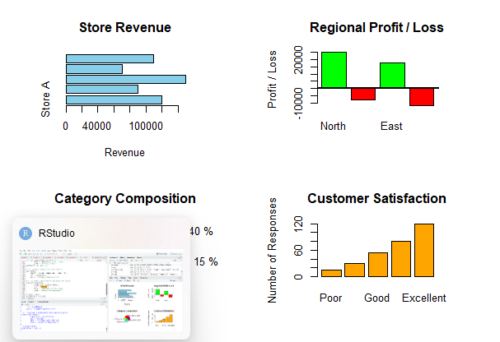

Question 2:
a) Given that monthly active users grew exponentially, what axis scale should the trend chart use? Justify with a
brief worked example.
b) Propose a chart for examining the relationship between price and rating across 200 products, and explain how
you would handle overplotting if many products cluster together.
c) Design a dashboard combining category revenue and the user growth trend, with an annotation on the month
of fastest growth.
d) Write a one-sentence narrative takeaway that a non-technical executive could understand from your
dashboard.

a) Axis Scale for Exponential User Growth

Use a logarithmic (log) scale on the Y-axis because exponential growth appears as a straight line on a log scale, making growth trends easier to interpret.

Worked Example:

Month | Users
Jan | 100
Feb | 200
Mar | 400
Apr | 800
May | 1600

On a linear scale, the increase becomes steeper each month.
On a log scale:
- log₁₀(100) = 2.00
- log₁₀(200) = 2.30
- log₁₀(400) = 2.60
- log₁₀(800) = 2.90
- log₁₀(1600) = 3.20
These values form an approximately straight line, clearly showing the constant growth rate.

b) Chart for Price vs Rating

Use a Scatter Plot.
- X-axis: Price
- Y-axis: Rating
- Each point: One product
Handling Overplotting:
- Use semi-transparent points (alpha).
- Use smaller point sizes (pch = 16, cex = 0.6).
- Add jitter if many products have identical values.
- Alternatively, use a hexbin or 2D density plot for very dense data.

c) R Code – Dashboard

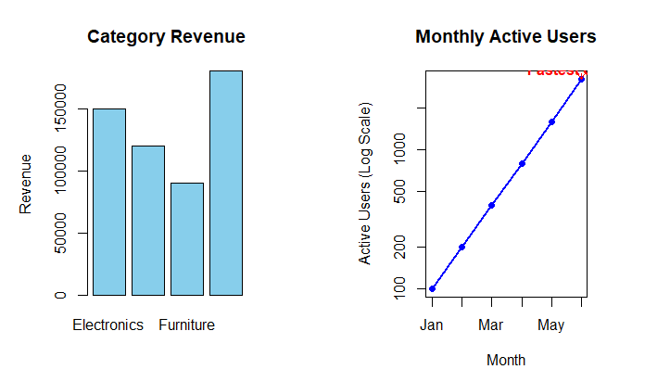

d) One-Sentence Narrative
The dashboard shows that user growth accelerated rapidly in the final month while category revenue remained strong, indicating that the business is successfully expanding its customer base and sales simultaneously.

